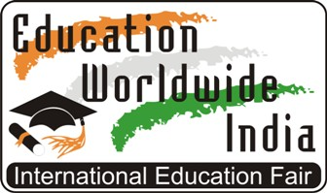

www.eduworldwideindia.com

India International Education Fair - Education Worldwide India

India is one of the most promising countries today and Indian Students have reached to universities in more than 100 countries across the globe to study the most innovative and most promising courses. Some of the leading Multinational companies are headed by Indians who have dared to think big and have given a momentum to their career / education by studying in the diverse culture of International Universities.

Education Fair is one of the most sincere and informative platforms where students can interact with the representatives of leading Universities Worldwide. In the world of digital learning and information, one can easily get the details about anything across the globe but when it comes to selecting the right university or career, seeing is believing takes the front seat. With this thinking in mind, Global Events & Expositions P. Ltd., a New Delhi based, professional exhibition company registered under Ministry of Corporate Affairs, Government of India has been organizing India International Education Fair – Education Worldwide India since year 2004.

Education Worldwide India Fairs are famous in India for hosting universities from across the globe. In the last 20 years, 250+ fairs have been organized in about 40 cities across India and Universities & Institutions from 65+ countries have participated to interact with Indian Students. Schedule for 2023 has been announced:

Education Worldwide India Fairs - Spring 2023 Series:
- New Delhi - 16th April 2023
- Mumbai – 18th April 2023
- Bangalore - 20th April 2023
- Chennai – 22nd April 2023
- Hyderabad – 23rd April 2023

Education Worldwide India Fairs - Fall 2023 Series:
- New Delhi – 26th November 2023
- Mumbai – 28th November 2023
- Bangalore - 30th November 2023

Education Ministries, Education Promotion Organizations, Universities and other Education Institutions are encouraged to evaluate the possibility of leveraging this great opportunity to reach out to the student community in India.

The complete details regarding India International Education Fair – Education Worldwide India is available on www.eduworldwideindia.com

To get any specific detail / information, please connect with:

Mr. Siddharth Jain
Chief Strategy Officer
+919811663707
Education Worldwide India Fairs
siddharth@eduworldwideindia.com
educationfairs@gmail.com

Organized By:
Global Events & Expositions Private Limited
J – 189, Basement, Saket, New Delhi – 110 017, India
www.eduworldwideindia.com | info@eduworldwideindia.com | +919311015777

