The Stages to be Followed by Foreign Students in Their Applications

https://obs.usak.edu.tr/oibs/ina_app/
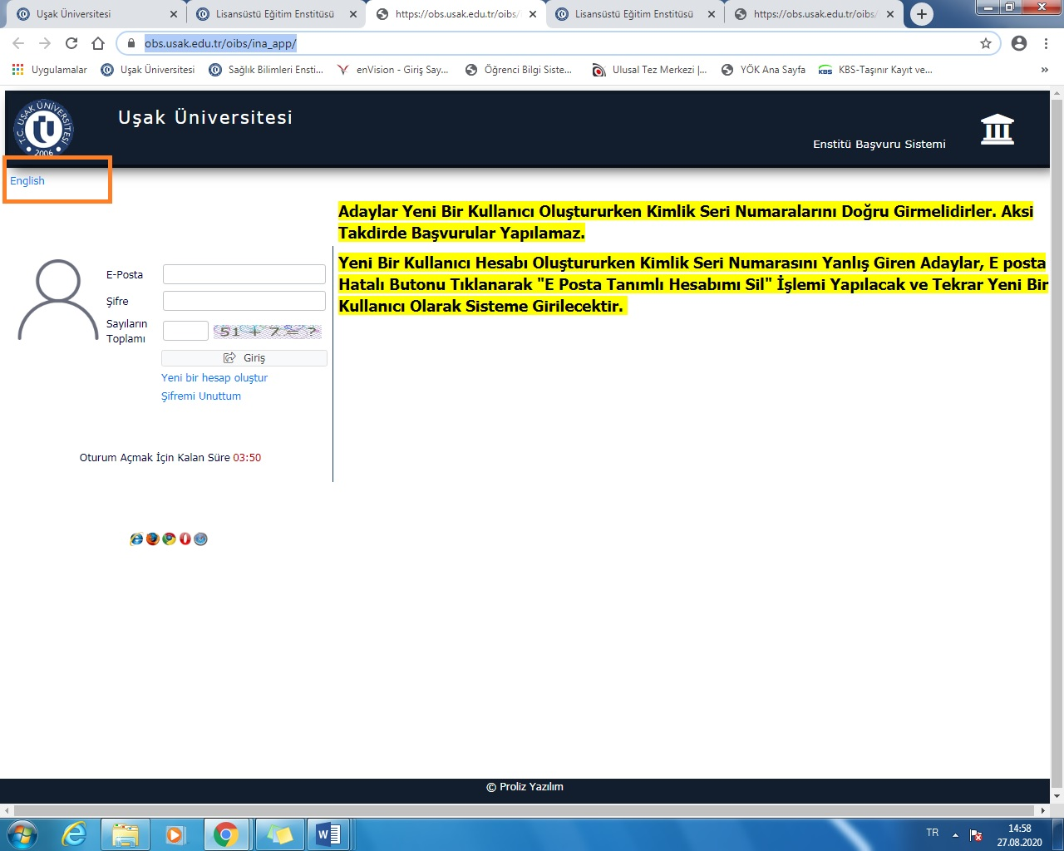

(Step 1) https://obs.usak.edu.tr/oibs/ina_app/ (English Site)
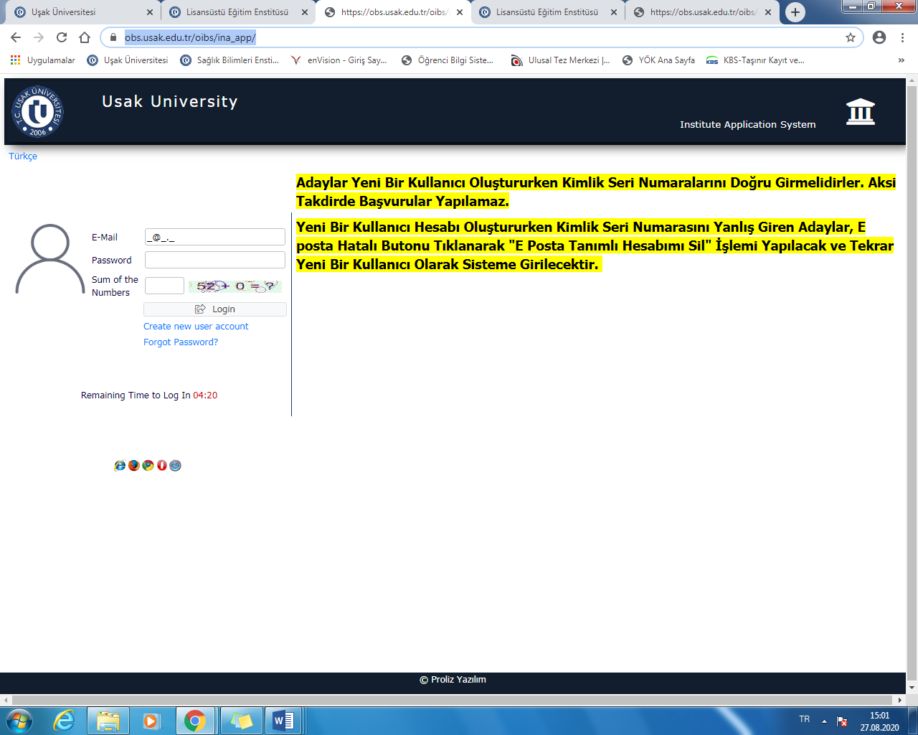

(Step 2) Create New Account
https://obs.usak.edu.tr/oibs/ina_app/
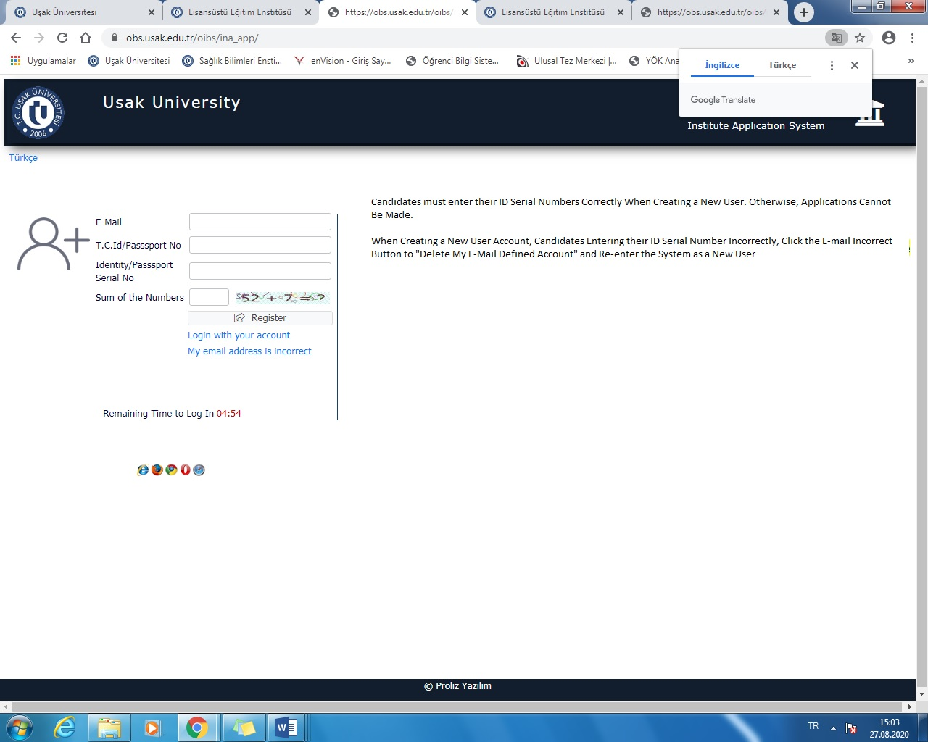
Enter the e-mail address, TC / passport number, passport serial number shown in the picture above and click register.

Your password will come to your e-mail address, enter your e-mail address and password in the boxes in step-1.

Step 3 Click “Published Application”

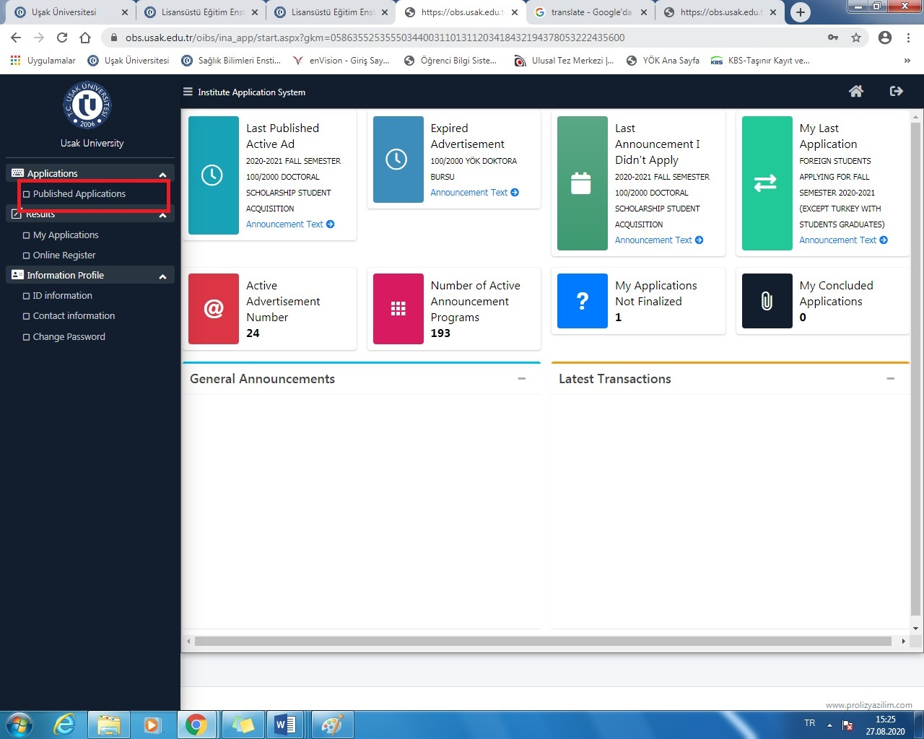

Step 4 After clicking on the field that suits you, the fields you will choose will open at the bottom of the page.
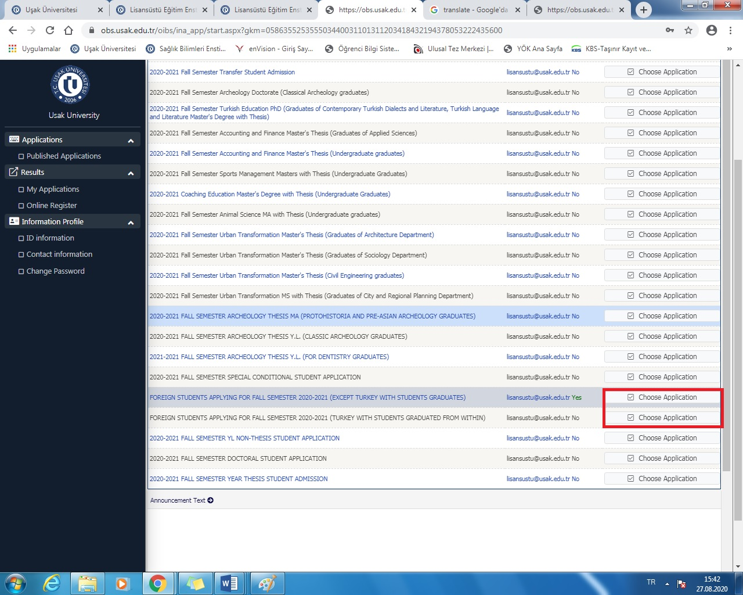

Step 5 After clicking on the field that suits you, the fields you will choose will open at the bottom of the page. Find your area by progressing in the area that opens and click “Add New Applications”
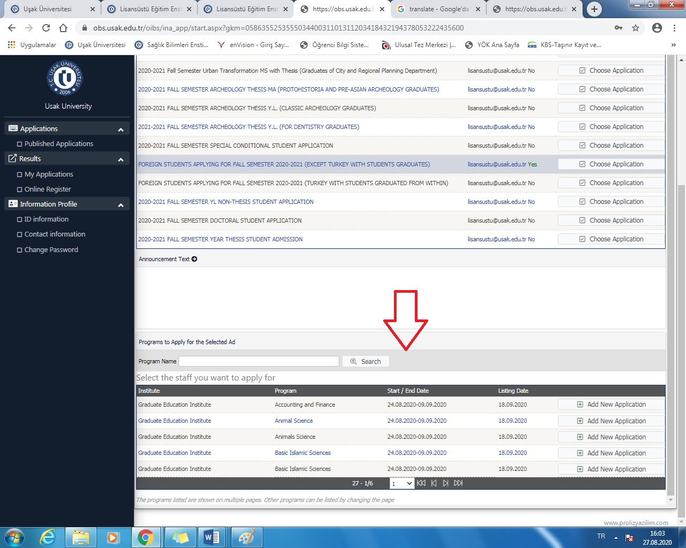

Step 6 After completing your identity information completely, go to the next step and upload the required documents to the system in pdf format and save your application.
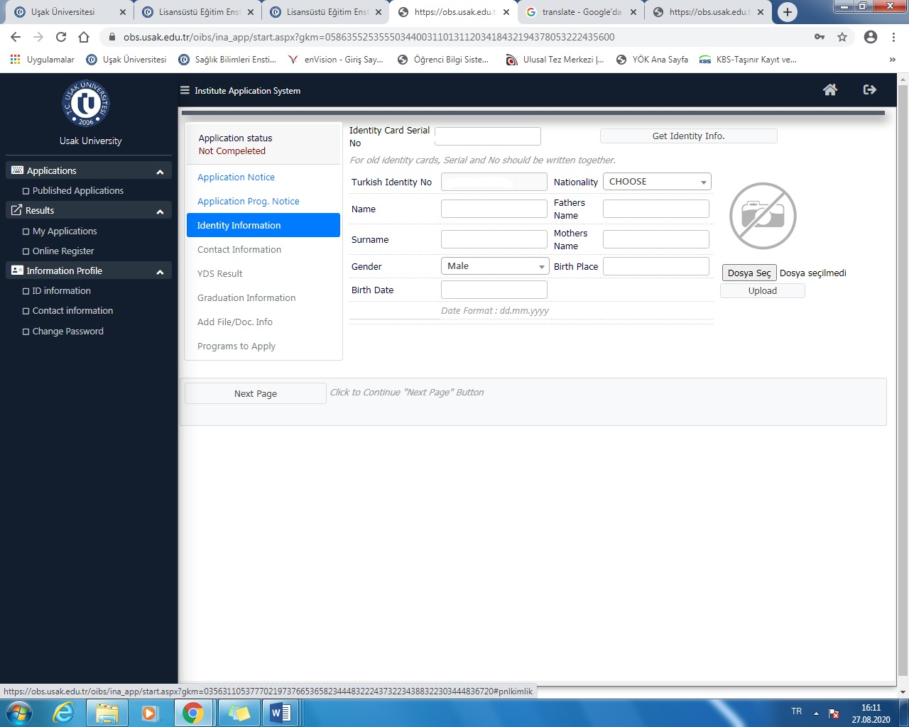

NOTE 1: If you meet any problem, please send e-mail to : lisansustu@usak.edu.tr
NOTE 2: If you cannot apply online, please send the following documents by e-mail. (for Phd application)

APPLICATION FORMS FOR THE FOREIGN STUDENTS WHO GRADUATED ABROAD:

1-Diploma or certified copy of Graduation Document (Translated)
2-Certificate of Recognition from the Higher Education Council (If you have)
3-Transcript (Translated)
4-Copy of Passport
5-Foreign language certificate for the PhD students
6-Turkish Proficiency Certificate (If you have)

